MIM V3 — test case TC-04: investigate INC2667546 on Automated Claim Transaction PROD
Dashboard | MIM V3, Kibana 9.5.3
Objective | Show that an incident on an application service, a CI that is not a server, can still be investigated end to end: its owners, its CMDB links, its application's health and, once one of its servers is picked, that server's health
Why this incident | Round 15 picked it for TC-04. Its CI is a Mapped Application Service with rich CMDB links, an APM-instrumented business application, and servers that send metrics
Result | Pass. Every panel filled once the server vslrau1p276 and the service clmact were picked; before that, the server panels were empty, as expected for a CI that is not a server
How the dashboard is read
The dashboard is read top to bottom, like an investigation:
- Section 1: what is open right now, across all incidents.
- Section 2: what the affected CI is, who owns it, and what it is connected to.
- Section 3: how its applications, services and server are doing.
The controls at the top decide what sections 2 and 3 show. Here the incident's CI is an application service, so the server panels also need a server: one of its servers is picked in the Server control (section 3).
Test flow
The path followed in this test, with what each step showed.
- Green: the step and its result.
- Amber: a decision.
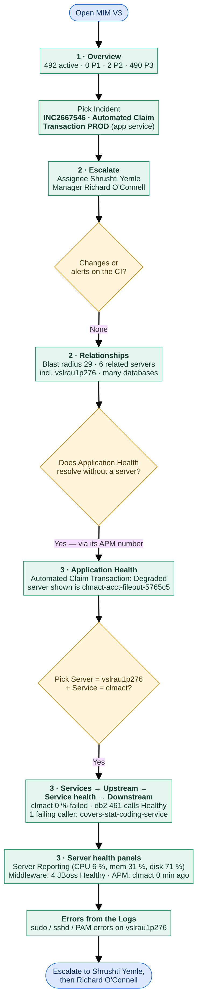
Inputs
Control | Value | Why
Incident | INC2667546 · Automated Claim Transaction PROD | The incident under test; its affected CI is an application service, not a server
CI | (no CI selected) | Not needed: an incident's CI always wins
Server | (no server selected), then vslrau1p276 | The CI is not a server, so the server panels stay empty until one is picked; vslrau1p276 is one of its servers in Server View
Health window | 24 hours | How far back the health panels look
Service | (services on this CI), then clmact | clmact is the application's own APM service; drives Upstream / Service health / Downstream
Application | (all applications), then Automated Claim Transaction | The business application of the CI; drives Services of the Application

Step 1 — Major Incident Overview
What to show: the starting point for the MIM lead. Before picking anything, section 1 answers "how bad is it across the estate?"
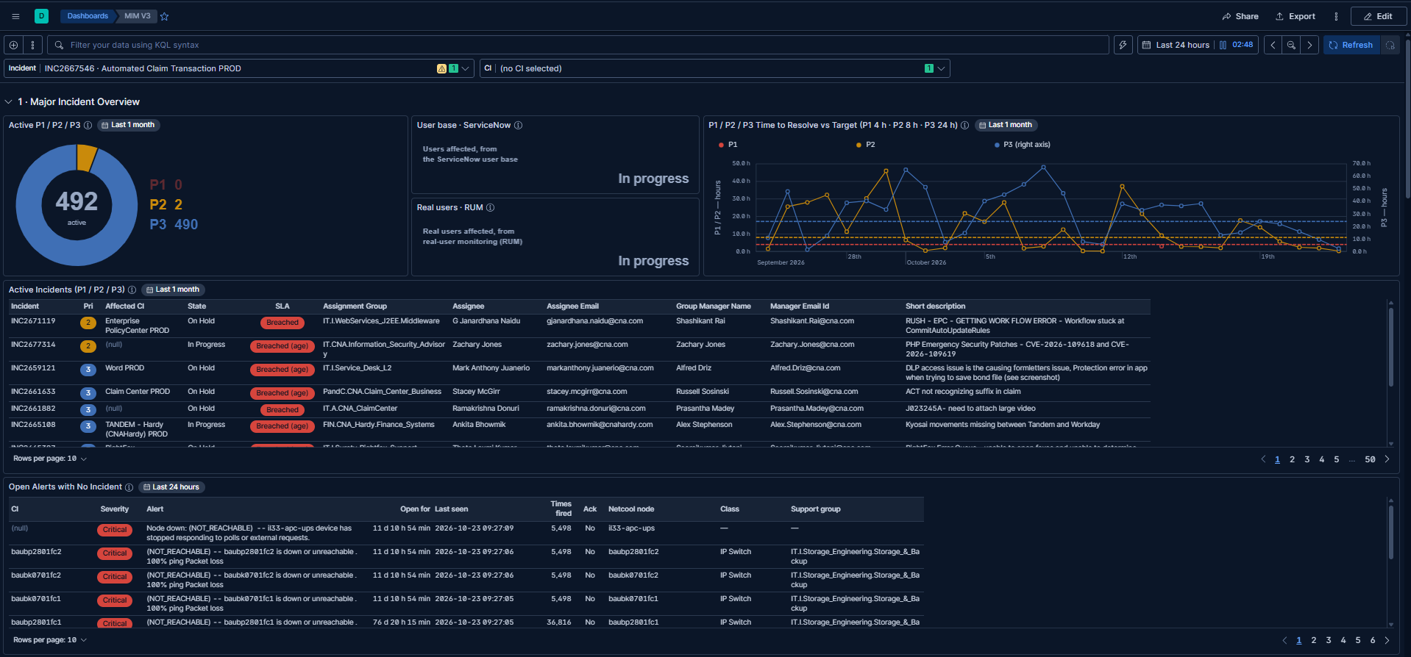
Check | Result
Controls hold the inputs above | ✅
Active P1 / P2 / P3: 492 active (P1 0, P2 2, P3 490) | ✅
Time to Resolve vs Target: P1 / P2 on the left axis, P3 on the right axis, dashed targets | ✅
Active Incidents: SLA, assignee and manager per incident | ✅
Users impacted: User base · ServiceNow and Real users · RUM, both "In progress" | ✅ placeholder
Open Alerts with No Incident: open Netcool alerts on CIs with no open incident | ✅
Notes:
- Donut: no P1 is open; most of the load is P3.
- Active Incidents: "Breached" comes from a ServiceNow SLA record; "Breached (age)" means there is none, so the incident's age is compared with the target.
- Open Alerts with No Incident: several switches have been unreachable for 11 days with no ticket: possible blind spots worth raising.
- Users impacted: waiting for the ServiceNow user base and RUM integrations.
Step 2 — Escalation, changes and alerts
What to show: who owns the CI, and whether anything changed or alerted on it.
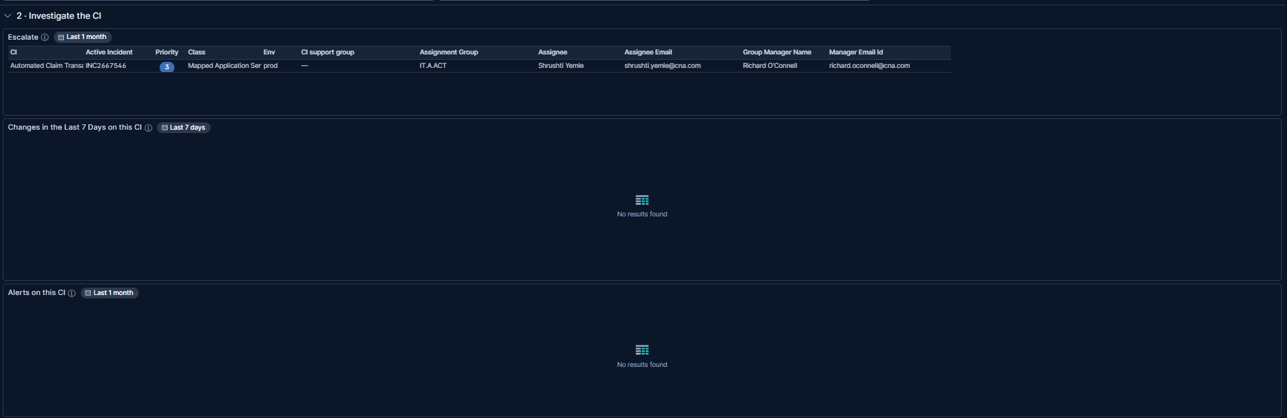
Check | Result
Escalate: Automated Claim Transaction PROD · INC2667546 · P3 · Mapped Application Service · prod; assignment group IT.A.ACT, assignee Shrushti Yemle, manager Richard O'Connell | ✅
CI support group: empty (—) | ✅ expected (not set in the CMDB for this CI)
Changes in the Last 7 Days: empty | ✅ expected (no changes on this CI)
Alerts on this CI: empty | ✅ expected (no Netcool alerts on this CI)
Notes:
- Escalate works for an application service as for a server: who to call comes from the incident and the CMDB, not from metrics.
- CI support group is blank in the CMDB for this CI: a data gap to raise, not a dashboard fault.
- Changes and Alerts empty rule out a recent change or a Netcool alert on the CI itself.
Step 3 — The CI's relationships
What to show: what depends on the application service and what it runs on, straight from the CMDB.
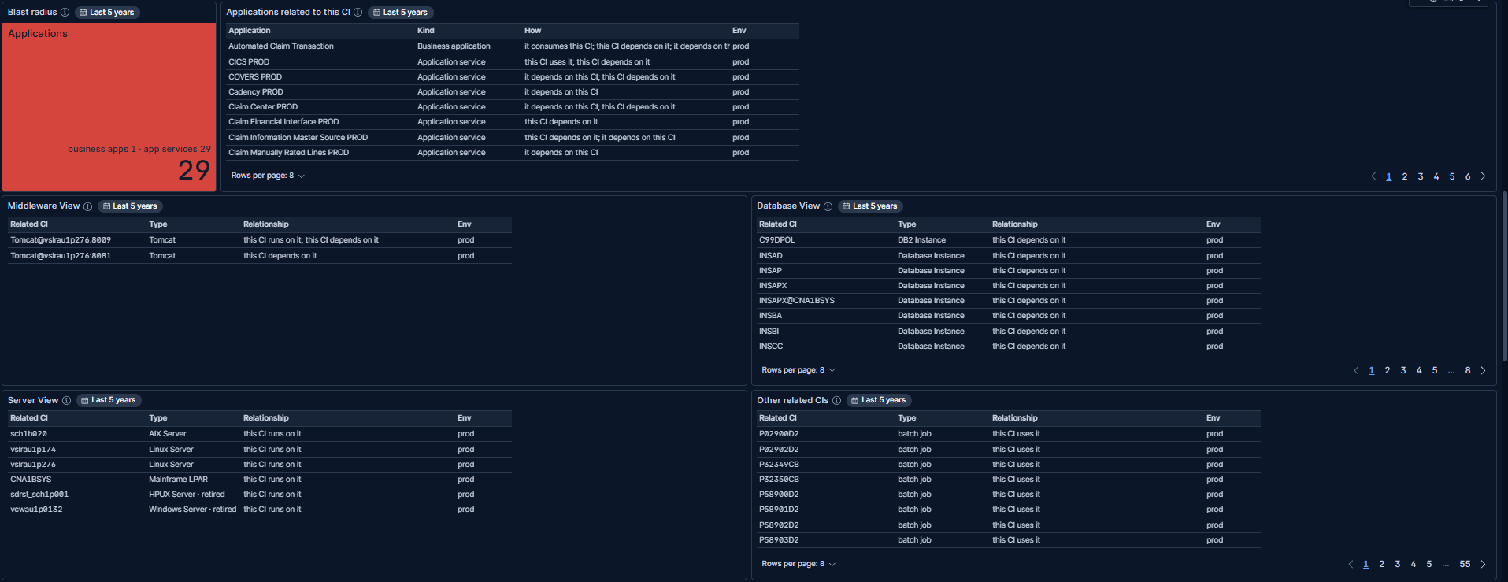
Check | Result
Blast radius: 29 (business apps 1 · app services 29) | ✅
Applications related to this CI: Automated Claim Transaction (business application), CICS PROD, COVERS PROD, Cadency PROD, Claim Center PROD … (6 pages) | ✅
Middleware View: 2 Tomcat instances on vslrau1p276 (ports 8009, 8081) | ✅
Database View: a DB2 instance and many database instances (8 pages) | ✅
Server View: sch1h020 (AIX), vslrau1p174 and vslrau1p276 (Linux), CNA1BSYS (mainframe LPAR), two retired | ✅
Other related CIs: batch jobs (55 pages) | ✅
Notes:
- Blast radius is red from 5: a failure of this application service touches 29 applications.
- Server View is the key to section 3: it names the servers this application service runs on. vslrau1p276 is picked from here in step 5.
- Retired CIs are kept and marked "· retired", so old links stay visible without being mistaken for live ones.
Step 4 — Application health, before picking a server
What to show: what section 3 shows for a CI that is not a server.
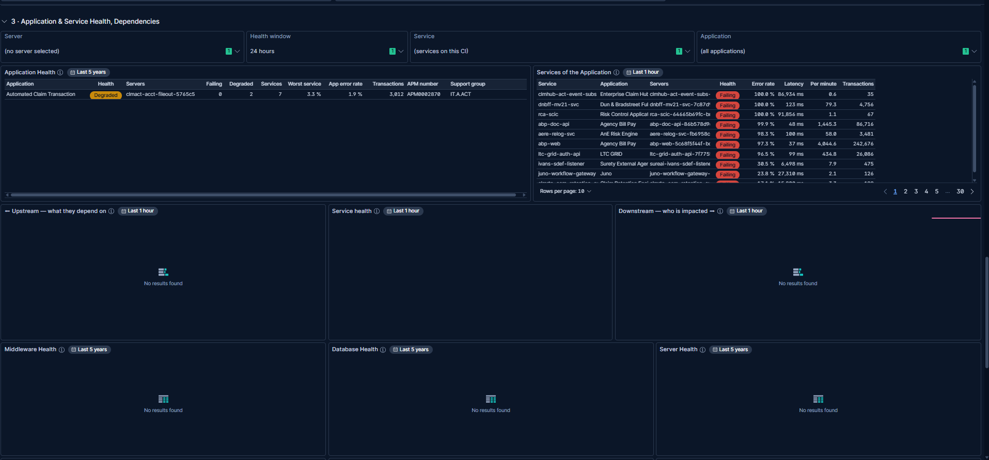
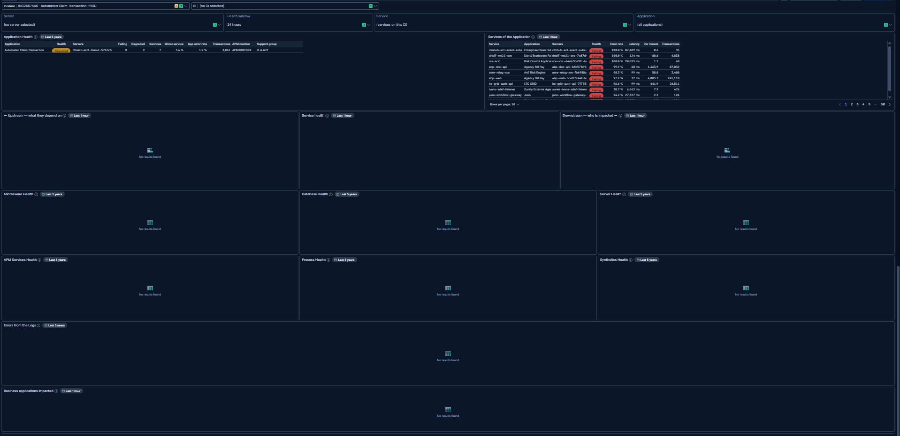
Check | Result
Application Health: Automated Claim Transaction, Degraded; 7 services, 2 degraded, worst service 3.3 %, application error rate 1.9 %; APM number APM0002870, support group IT.A.ACT | ✅
Services of the Application: every production service, worst first | ✅ expected (Application still on (all applications))
Upstream, Service health, Downstream: empty | ✅ expected (no APM service runs on this CI itself)
Middleware, Database, Server, APM Services, Process and Synthetics Health, Errors from the Logs: empty | ✅ expected (the CI is not a server, and no server is picked)
Notes:
- Application Health finds the CI's business application from the CMDB, so its health shows before any server is picked.
- The Servers column shows a Kubernetes pod name (clmact-acct-fileout-5765c5), not a CMDB server, so it can't be typed into the Server control. The CMDB servers come from Server View (step 3).
- Empty server panels are the expected result for an application service: they need a server.
Step 5 — Picking the server, service and application
What to show: section 3 once Server = vslrau1p276, Service = clmact and Application = Automated Claim Transaction are picked.
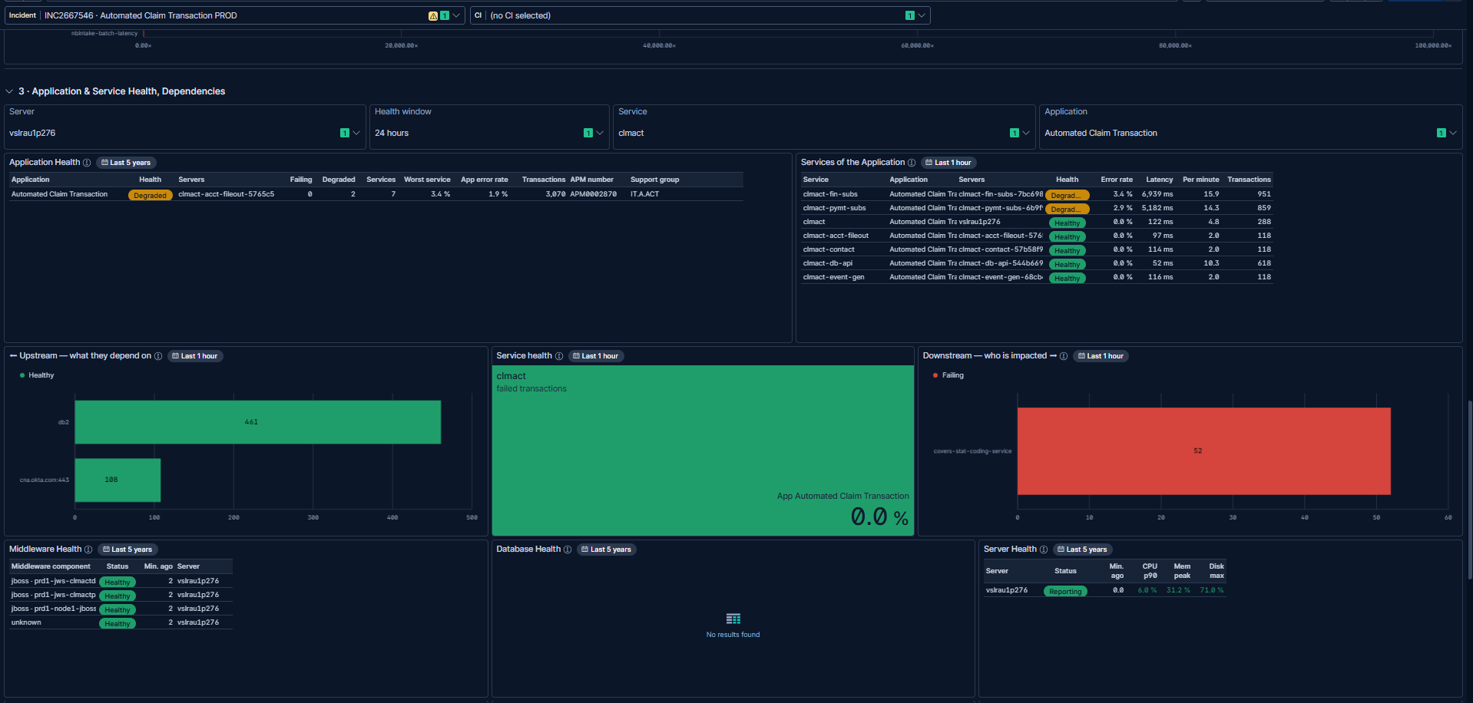
Check | Result
Services of the Application: the application's 7 services; clmact-fin-subs and clmact-pymt-subs Degraded (3.4 %, 2.9 %), the other 5 Healthy | ✅
Upstream: clmact depends on db2 (461 calls) and cna.okta.com:443 (108 calls), both Healthy | ✅
Service health: clmact, 0.0 % failed | ✅
Downstream: one failing caller, covers-stat-coding-service (52 calls) | ✅
Middleware Health: 4 components on vslrau1p276 (3 JBoss, 1 unlabelled), all Healthy | ✅
Database Health: empty | ✅ expected (no database on this server)
Server Health: vslrau1p276 Reporting; CPU p90 6.0 %, memory 31.2 %, disk 71.0 % | ✅
Notes:
- Picking one server from Server View fills the health panels: the same panels as TC-01, for the server behind the application service.
- Read the dependency row left to right: clmact depends on db2 and Okta (healthy) → clmact itself (0 % failed) → covers-stat-coding-service calls it and is failing. The failure is on the caller's side.
- Two services are Degraded (about 3 % failed): the reason Application Health shows Degraded.
Step 6 — The server's health, logs and related dashboards
What to show: the rest of the server's health, and the log signal.
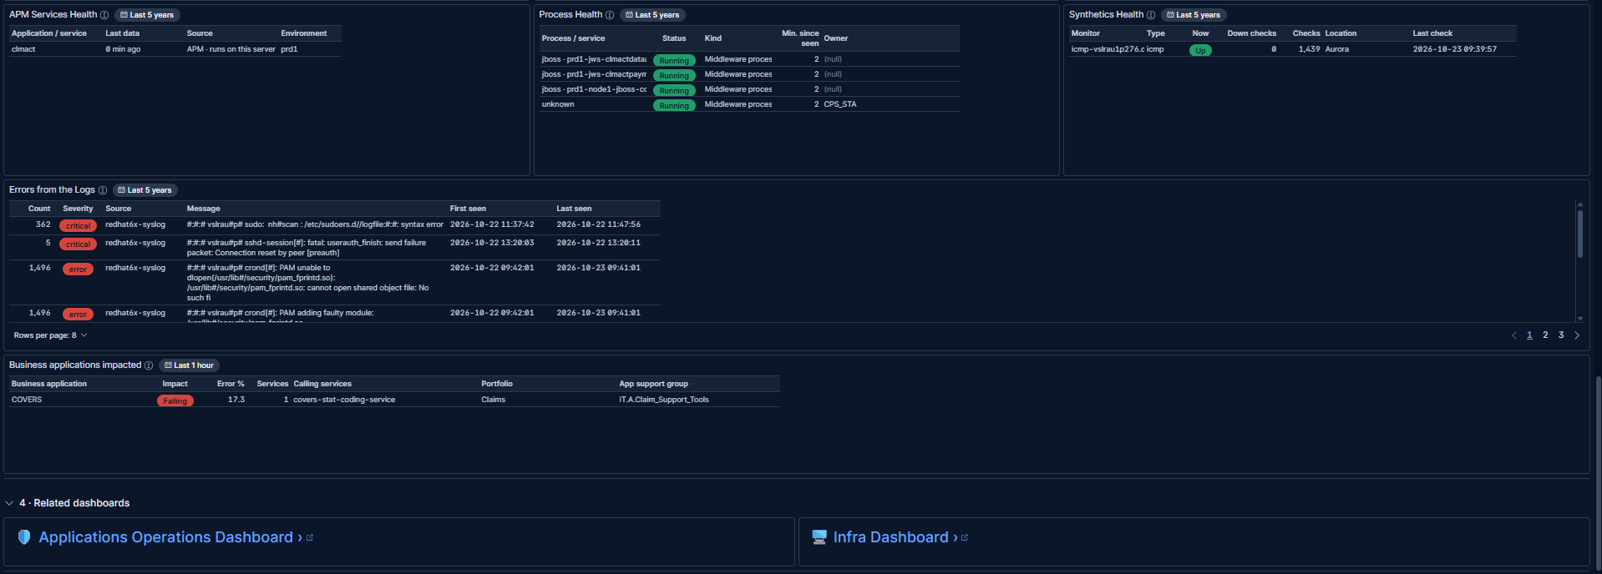
Check | Result
APM Services Health: clmact, data 0 min ago, runs on this server, prd1 | ✅
Process Health: 4 middleware processes Running | ✅
Synthetics Health: ping monitor on vslrau1p276 Up, 0 down checks out of 1,439, from Aurora | ✅
Errors from the Logs: critical sudo syntax errors (362) and sshd resets (5), recurring crond PAM errors (1,496), from redhat6x-syslog | ✅
Business applications impacted: COVERS Failing, 17.3 % errors, calling service covers-stat-coding-service; portfolio Claims, support group IT.A.Claim_Support_Tools | ✅
Links to the Applications Operations and Infra dashboards | ✅
Notes:
- Synthetics checks the server from outside: it is reachable.
- What the logs show: a sudoers syntax error repeated 362 times and recurring PAM module errors from cron: configuration problems for the assignee to confirm, not necessarily the incident's cause.
- Business applications impacted names the business owner of the failing caller: COVERS (Claims), the team to tell.
- Dashboard version: captured on 23 Oct. Since then section 1 shows Active P1 / P2 over 8 h / P3 over 24 h tiles instead of the donut, and SLO Error Burn Rate and Business applications impacted have been removed (Downstream lists the same failing caller).

Outcome
- Pass: an application-service incident can be followed end to end. Without a server, the dashboard shows the CI's owners, its CMDB links and its application's health; picking one of its servers from Server View fills the server panels.
- The application is Degraded, not down: 2 of its 7 services fail about 3 % of transactions, and clmact's caller covers-stat-coding-service (COVERS) is failing.
- The server vslrau1p276 is healthy (reporting; CPU 6 %, memory 31 %, disk 71 %); its logs show sudo and PAM configuration errors worth checking.
- Escalate to: Shrushti Yemle (assignee), then Richard O'Connell (manager); both are named in Escalate. Tell the COVERS team about covers-stat-coding-service.

